#include<reg51.h>

void delay(void);

void main(void)

{

P0=0x00;

for(;;)

{ delay();P0=0x01;

delay();P0=0x02;

delay();P0=0x04;

delay();P0=0x08;

delay();

P0=0x10;//00010000

delay();

P0=0x20;//00100000

delay();

P0=0x40;

delay();P0=0x80;

delay();

}

}

void delay(void)

{

unsigned int y;

for(y=0;y<30000;y++);

}

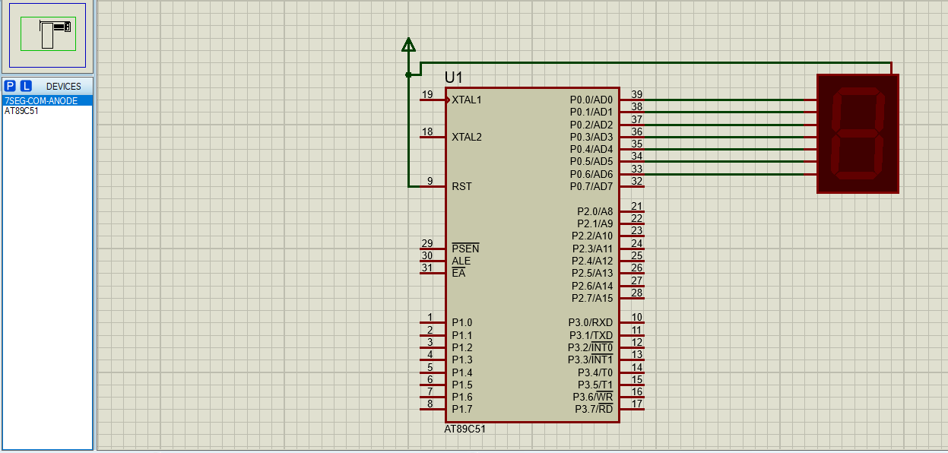

Displaying different numbers in seven segment display active low. Common anode.

#include<reg51.h>

void delay(void);

void main(void)

{

P0=0x00;

for(;;)

{

//P0 = 0x01; //0000 0001

//P0=0x02;//0000 0010

//P0= 0x04; //0000 0100

P0= 0xF9; //1111 1001 // 1

//delay();

}

}

void delay(void)

{

unsigned int y;

for(y=0;y<30000;y++);

}

